Week 3  Allergens are highlighted in red | Monday | Tuesday | Wednesday | Thursday | Friday
Main course 1  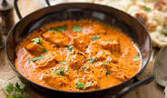 | Arabiata Style Chicken | Sweet & Sour  Pork | “Potato Puff”  Beef Hot Pot | Chicken in a  “Herbs De Provence” & Tomato Sauce | A Peppery Southern Fried Chicken Breast  gluten, egg, wheat, dairy, milk  Oven Baked Cumberland Sausages  Gluten
Main course 2  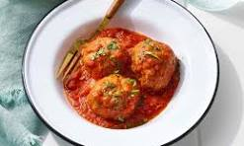 | Meatballs in a Rich Marinara Sauce  Gluten | Creamy Chicken Korma  milk | Lincolnshire Sausages in a Rich Tomato Sauce  Gluten | Minced Beef Bolognaise with fresh Herbs | Jacket Potatoes  dairy
Vegetarian option  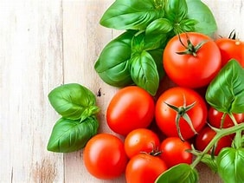 | “Sri Lankan” Butternut Squash & Aubergine Curry  vegan | Steak Less  Pasty  gluten, soya, wheat  vegan | Potato, Leek, Onion & Cheese Bake  dairy, milk | Half a Stuffed Red Pepper  gluten, Wheat  vegan | Vegan, Glamorgan Style Sausages  wheat

