Week 1  Allergens are highlighted in red | Monday | Tuesday | Wednesday | Thursday | Friday
Main course 1  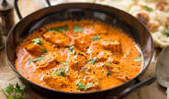 | Aromatic Chicken Tikka Masala  milk | Traditional Slow Cooked Beef  Lasagne  wheat, gluten, milk, dairy, egg | A Peppery Southern Fried Chicken Breast  gluten, egg, wheat, dairy, milk  Cumberland Sausages  Gluten | Spiced Mexican Style Chicken | Jerk Style Chicken with a Jamaican Marinade
Main course 2  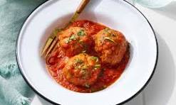 | Pork Meatballs in Marinara Sauce  gluten  Vegan “Balls” in Tomato Sauce  soya | Chicken in an Italian Plum Tomato & Mascarpone Sauce  dairy, milk | Jacket Potatoes  dairy | Cheese & Tomato pasta Bake  wheat, gluten, milk, dairy | Baked Mac and  Cheese  wheat, gluten, milk, dairy
Vegetarian option  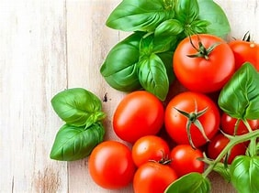 | Creamy cauliflower & red Pepper Curry | Mediterranean  Roast Vegetable Lasagne  wheat, gluten, milk, dairy, egg | Vegan, Glamorgan Style Sausages  wheat | Cannelloni Verde  wheat, gluten, milk, dairy | Sweet Potato & Chick Pea Curry

