Week 2  Allergens are highlighted in red | Monday | Tuesday | Wednesday | Holi Day | Friday
Main course 1  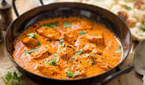 | A Peppery Southern Fried Chicken Breast  gluten, egg, wheat, dairy, milk  Oven Baked Cumberland Sausages  Gluten | Minced Lamb Hot Pot with Crispy Sauté Potatoes | Rich & Spicy Beef Chilli Con Carne | A Celebratory Holi Day Menu | “Deconstructed”  Hunters Chicken  gluten, egg, wheat, dairy, milk  Halal, no bacon
Main course 2  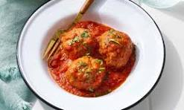 | Jacket Potatoes  dairy | Pork & Beef Meatballs in a Rich Marinara Sauce  gluten | Halal Beef Pepperoni in Tomato Sauce  gluten | A Celebratory Holi Day Menu | Cheese & Tomato Tri Colour Pasta Bake  gluten, egg, wheat, dairy, milk
Vegetarian option  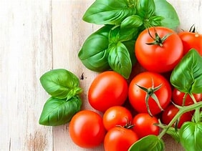 | Vegan, Glamorgan Style Sausages  wheat | Cheese & Onion Pasty  gluten, egg, wheat, dairy, milk | Mixed Beans in a Tex Mex Sauce | A Celebratory Holi Day Menu | Mushroom Stroganoff  dairy

