16th September 2022

Dear Parents/Carers,

Year 10 Standards evening

Dear Parents/Carers,

I would like to invite you to the Year 10 Standards Evening, which is scheduled to take place on Tuesday 27th September 2022 at 7.00 pm in the school hall.

Standards Evening formally provides you with information about the expectations of the year ahead. Commitment, aspiration, respect, integrity and community will be highlighted as our core values as well as ways in which you, as parents, can help your son. This will also be an opportunity to hear more about work experience and the Duke of Edinburgh Award.

The evening is an important date in the school calendar and, being a formal occasion, your son should attend and be in full school uniform. As there is limited seating in the school hall we would ask that, where possible, only one parent attends with their son.

Yours faithfully,

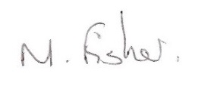

Dr M. Fisher
Head of Year 10

